Introduction

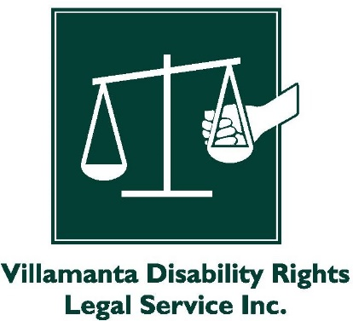 | Villamanta is a disability legal service.
 | Villamanta talked at VALID’s ‘We Can’t Be Beaten’ conference.
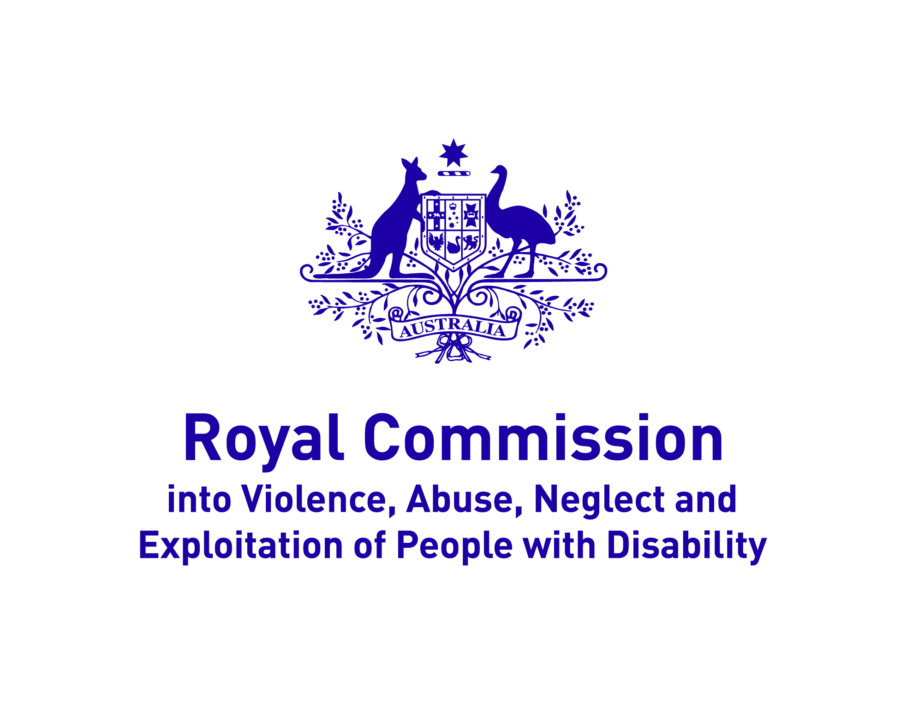 | Villamanta talked about the Disability Royal Commission.
 | People who talk to the Royal Commission might need legal advice.
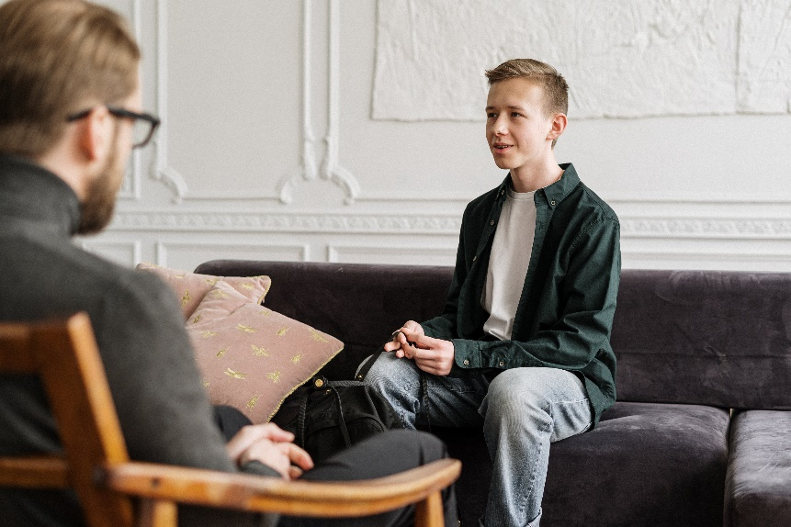 | People might need counselling because of bad things that have happened.
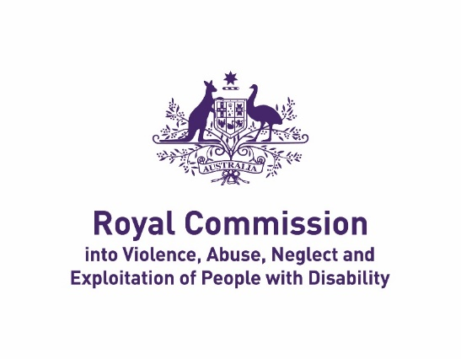 | But this fact sheet just talks about what the Royal Commission does.
If you need legal advice, contact Your Story through their website:
https://yourstorydisabilitylegal.org.au/Contact-us

If you need counselling, look for services on this website:
https://disability.royalcommission.gov.au/counselling-and-support
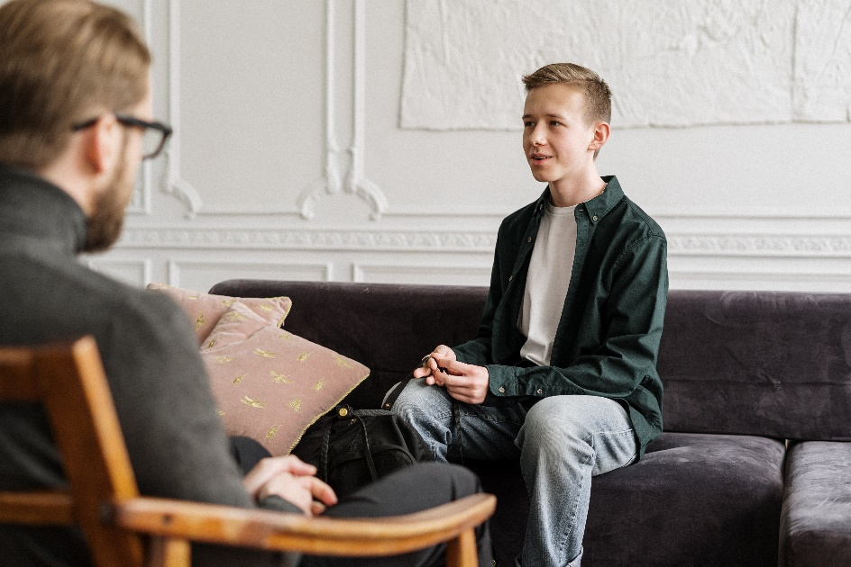

Information

 | Sometimes support providers treat people with disability badly.
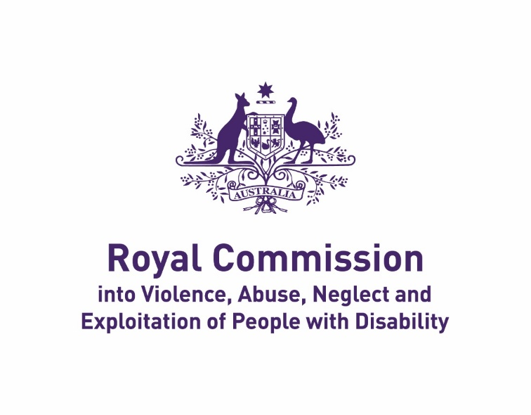 | Some people with disability want to know if they should talk to the Disability Royal Commission.

What does the Royal Commission do?

They talk to people about bad things that happen to people with disability.
They will tell the government what needs to change.

They do not give anyone money or help anyone fix bad things straight away.
Why talk to the Royal Commission?

 | It will help change the disability system.
 | The Royal Commission will not give anyone money or help fix bad things straight away.
 | People say it feels really good to be listened to by the Royal Commission.
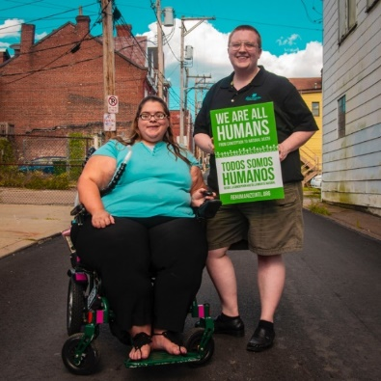 | Your story might also help other people.
How you can talk to the Royal Commission

- Make a submission

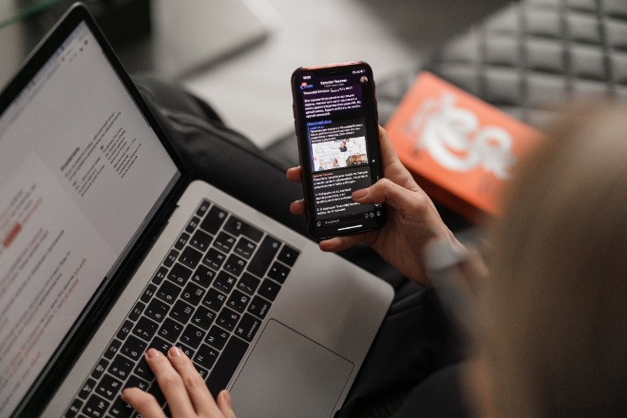  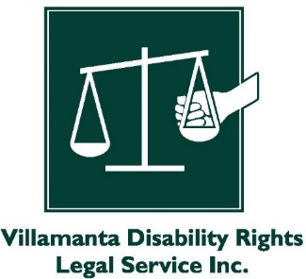 | This means you tell the Royal Commission what happened. Some people do this in writing.  Other people do this by:  - Telephone  - Making a video  - Making a recording  - Artwork  You can call Villamanta to get help if you want. We can come to you or talk to you on Zoom.
 | You or Villamanta would write the information then send it to the Royal Commission.
 | If you use the name of anyone who did something wrong, they might find out.
You or Villamanta could fix that by:

Not using the provider or person’s name

Not saying anything that makes it obvious who you are talking about

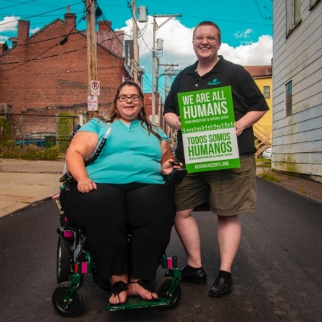 | The Disability Royal Commission will not punish anyone, even if they did the wrong thing.  They just want to hear your story to help people in future.
- Have a Private Session
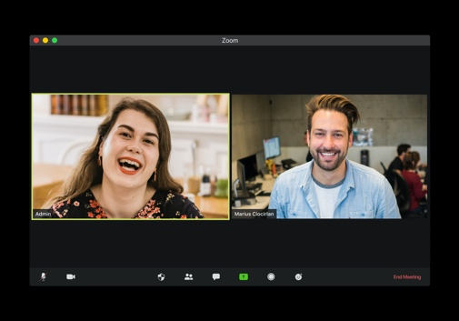 | This means you talk to someone at the Disability Royal Commission.  You would do this in person, by video conference (like Zoom), or on the telephone.
 | You can call Villamanta to get help if you want. We can come to you or talk to you on Zoom.
 | If you use someone’s name, they cannot find out what you said.
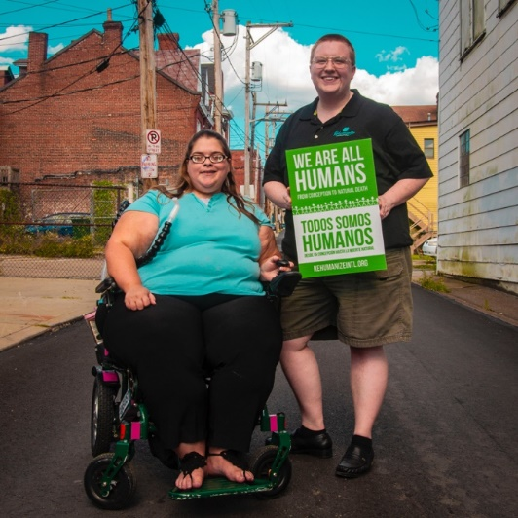 | The Disability Royal Commission will not punish anyone, even if they did the wrong thing.  They just want to hear your story to help people in future.
- Talk at a Public Hearing

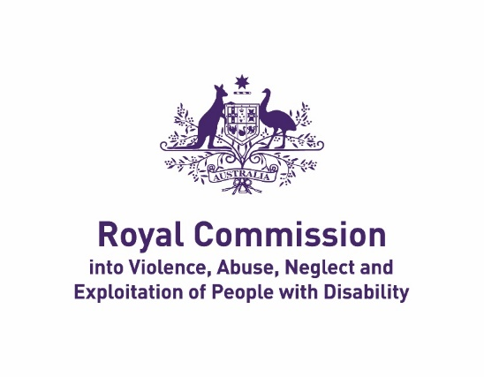 | This means you talk to people at the Royal Commission.
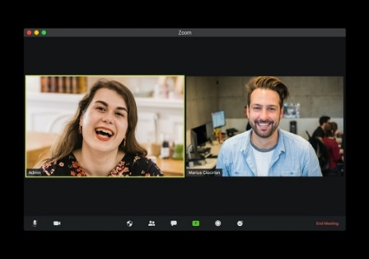 | You do this in person or by video conference (like Zoom).
 | You can call Villamanta to get help if you want. We can come to you or talk to you on Zoom.
 | You can ask the Royal Commission if you want to talk at a Public Hearing.
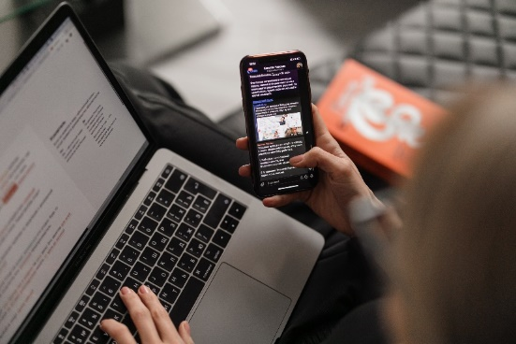 | You can also tell them what happened in a different way if you can’t talk at a Public Hearing.
 | Anything you say at a Public Hearing might go on the internet or in the newspaper.
 | You can ask Villamanta if you should get legal advice before you ask to talk at a Public Hearing.
Do you need help to understand this information? Contact Villamanta:
📱 1800 014 111
www.villamanta.org.au/contact

